Linked List
A Linked list is an ordered collection of finite homogenous data elements called nodes where the linear order is maintained by means(madhyam) of links or pointers. That is, each node is divided into two parts : the first part contains the information of the element and the second part called the link field or the next pointer field, contains the address of the next node in the list.
The number of pointers is maintained depending on the requirements and usage. Based on this, linked list are classified into four categories :
- Linear linked list
- Circular linked list
- Doubly linked list
- Circular doubly linked list

Linear Linked List :
In linear linked list, each node is divided in two parts: First Part contains the information of the element. And the second part contains the address of the next node in the list. That is , each node has a single pointer to the next node , and in the last node’s case a null pointer representing that there are no more nodes in the linked list. In singly linked list, the elements can be traversed only from left to right. A structure of the Linear Linked list is shown in figure.
Circular Linked List :
It just like a linear linked list in which the second part of the last node contains the address of the first node in the list i.e. , the second field of the last node does not point to the null pointer rather it points back to the beginning of the linked list. A structure of the Circular linked list is shown in figure.
Doubly Linked List :
Doubly linked lists are also called two-way lists. In the case of doubly linked list, two link fields are maintained instead of one as in singly linked list which help in accessing both the successor and predecessor nodes. A structure of the doubly linked list is shown in figure.
Circular Doubly Linked List:
A Circular Doubly linked list is one which has both successor and predecessor pointer in circular manner. The aim of considering circular doubly linked list is to simplify the insertion and deletion operations performed on doubly linked list. A structure of the Circular doubly linked list is shown in figure.

Linked List Operation :
The element can be inserted in linked list in 2 ways :
- Insertion at beginning of the list.
- Insertion at the end of the list.
We will also be adding some more useful methods like :
- Checking whether Linked List is empty or not.
- Linked List Traversal
- Searching any element in the Linked List
- Deleting a particular Node from the List

Applications of Linked Lists
- Linked lists are used to implement stacks, queues, graphs and Trees etc.
- Linked lists let you insert elements at the beginning and end of the list.
- In Linked Lists we don’t need to know the size in advance.

ADVANTAGES AND DISADVANTAGES OF LINKED LIST ORGANIZATION.
Advantage of Linked List Organization
- In Linked List Organization, insertion and deletion of elements can be efficiently done.
- There is no wastage of memory. The memory can be allocated and deallocated as per requirement.
- The Size is not fixed. They can grow or shrink during the execution of a program.
Disadvantages of Linked List Organization
- Linked Organization does not support random or direct access.
- Each data field should be supported by a link field to point to next node.
- The memory is wasted as pointer require extra memory for storage.

LINKED LIST VS. ARRAYS
The Comparison between linked list and arrays is as shown below :
Linked List | Array
The Linked List is a collection of nodes and each node is having one data field and next field.  For Example:   | The Array is a collection of similar type of data elements. In arrays the data is always stored at some index of the array.  For Example :  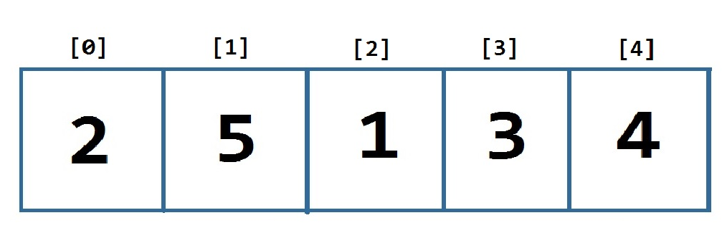
Any element can be accessed by sequential access only. | Any element can be accessed randomly. i.e. with the help of index of the array.
Physically the data can be deleted. | Only logical deletion of the data is possible.
Memory allocation is dynamic. Hence developer can allocate the memory And So no wastage of memory is there. | The memory allocation is static. Hence once the fixed amount of size is declared then that much memory is allocated. Therefore there is a chance of either memory wastage or memory shortage.

DOUBLY LINKED VS. SINGLY LINKED LIST
Comparison between Singly and Doubly Linked List
Singly Linked List | Doubly Linked List
Singly linked list allow you to go one way direction. | Doubly linked list has two way directions next and previous.
Singly linked list is a collection of node and each node is having one data field and next link field. | Doubly linked list is a collection of nodes and each node is having one data field, one previous link field and one next link field.  
Complexity of insertion and Deletion at known position is O(n). (Worst Case ) | Complexity at insertion and Deletion at known position is O(1)
No extra field is required: hence node take less memory in SLL.  Example: Telephone Directory | One field is required to store previous link hence node takes more memory in DLL
If we know in advance that element to be search is found near the end of the list, even then singly linked list, even then singly linked list traversed sequential from beginning. | In doubly linked list , if we know in advance that element to be searched is found near the end of the list, then the list can traversed from the end there by saving time.

ASSIGNEMENT: CIRCULAR LINKED VS. LINEAR LINKED LIST
Note: Do In Your Fair Copy

